STUDENT MANAGEMENT SYSTEM USING CORE JAVA

CONTENT

1.Acknowledgement

2.Introduction

3.Explanation

4.Explanation Procedure

5.Conclusion

**ACKNOWLEDGEMENT:**

First of all, I would like to thank my lecturer **Ms. AKANKSHA PANDEY** for helping me to acquire some basic knowledge of **“ Core Java Programming Language”**. At the same time, she gave me the opportunity to learn something new related to our module like constructors, methods, arrays ,junit, OOPS Concepts etc. Beside from my lecturer, I like to thank my other classmates for helping to understand the assignment related questions more clearly.

**INTRODUCTION :**

This assignment is based on developing a “**Student Management System”** using “Java Programming Language”. For that I used Core Java concepts and Data Structure in this development so that it will become more users friendly to interact. Besides, I also added text files for user’s records that are directly linked with this program. It is so called a heart of this program where all the functions depend on it.

**EXPLANATIONS :**

In this documentation I have given explanations of how to interact successfully with this Student Management System.I have explained here step by step so that it will surely help users to become more user friendly with it. Below is my explanations:

First Things First:

Before execute this program users need to do some works so that it will run properly into their system. First they need to make sure their system is having “JDK”

Depending on their system (Windows 64bit/32bit) they need to download and install. Then they need to add the “JAVA” files to their system “PATH” so that the system can run the program from CMD (Command Prompt). The path will show something like this “C:\Program Files (x86)\Java\jre1.8.0_25\bin;”. Now just add the address besides the current path directory and save it. The other way they can execute this program in to download the IDE (Integrated Development Environment) on their system. They can download ECLIPSE depending on the windows (32bit/64bit).

I developed this program using “ECLIPSE”.

**Execution Procedures:**

My project title is a “ Student Management System”. It is a console based project.It will display the basic details of student who is studying in the school .

First of all it will ask the user how many student details I have to show based upon the user given input it will take the input from the user .

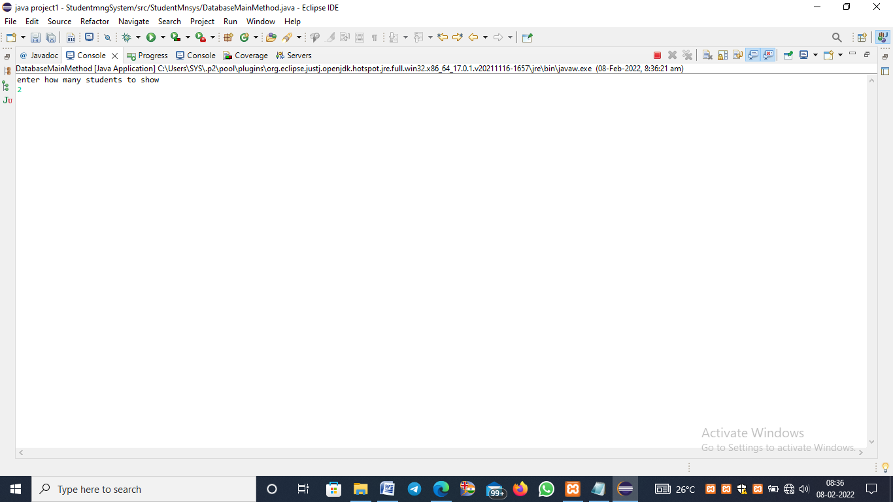

Of student name,location,course and then the fee payment

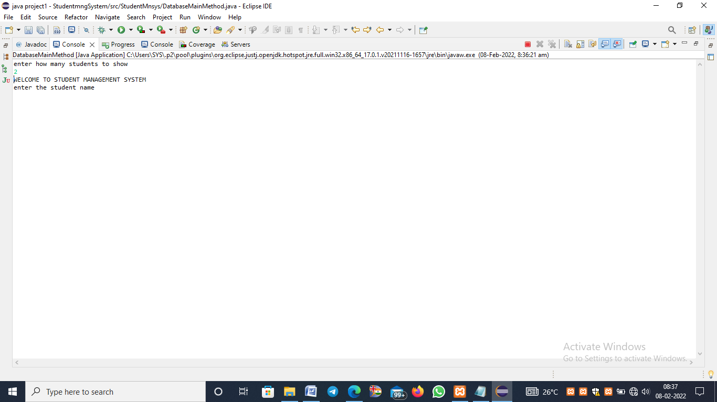

and then it will display the whole details of student after the execution of the program.

For student Id I used math.random() function to print the student id in random five digit number by using this function automatically it will display the id in 5 digit but in random number for different student it will show in different manner for all that I used the object and method creation function.

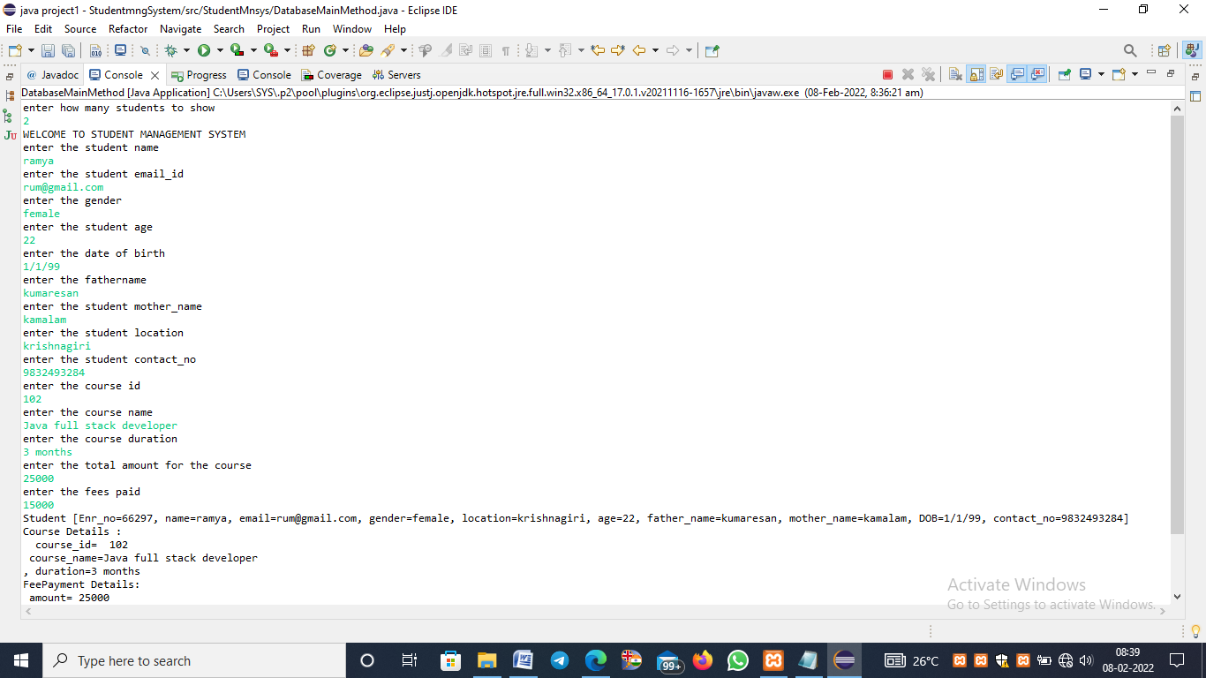

I used separate student,course,fee payment pojo files and one main method to execute the all function in that I created objects of course,student and then fee payment with the help of that object I called the methods it will perform the function and shown the output as a below format .

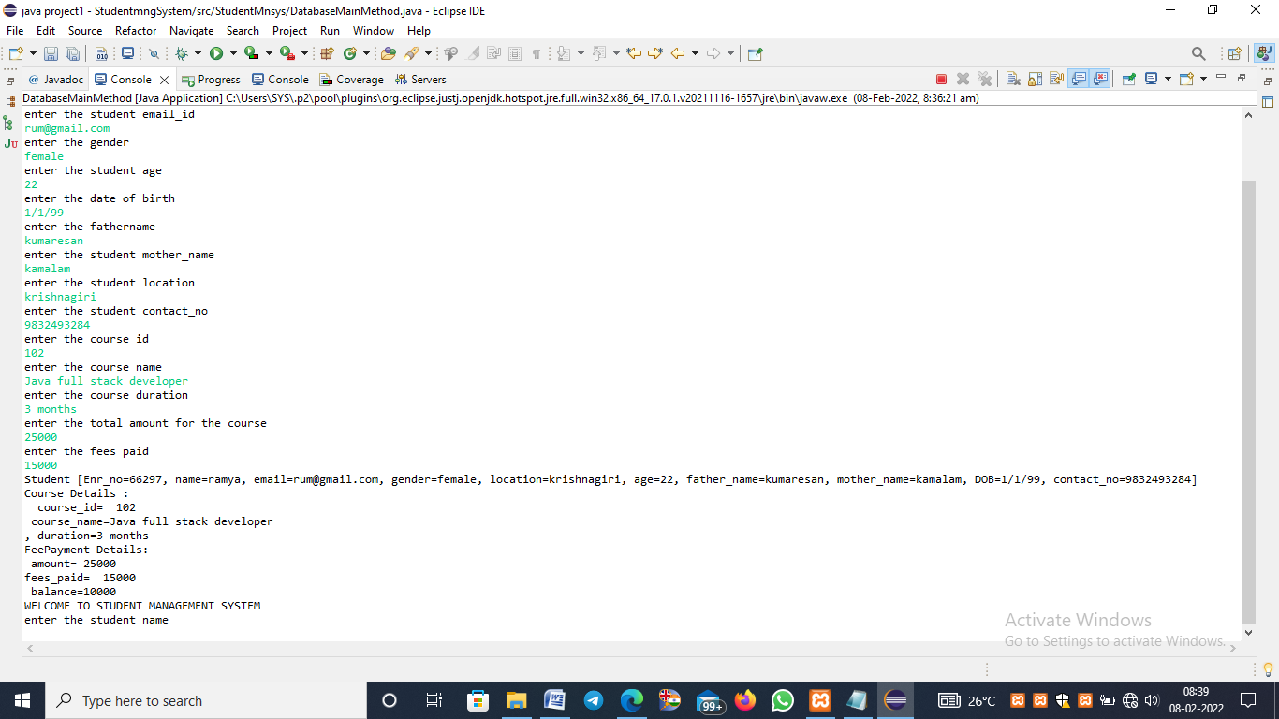

For student id i used the random method it will generate the number in the random manner as a double value but for 5 digit id i multiplied the number with 1000

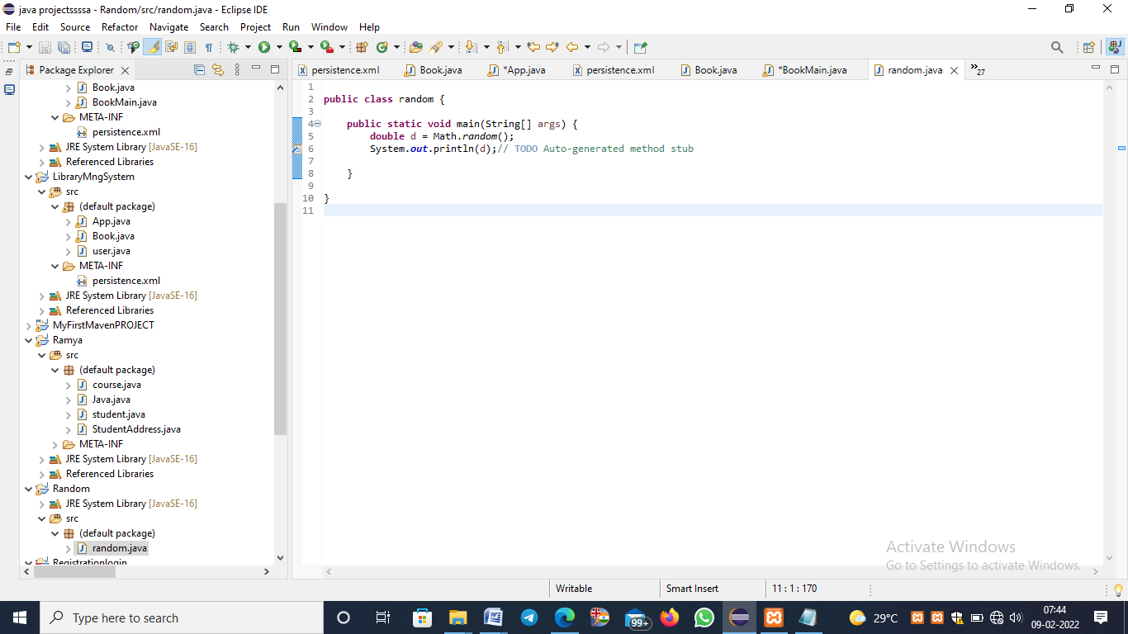

The above pic is the program for the random number it will show output in below manner.while executing everytime it will display the output differently in console screen.

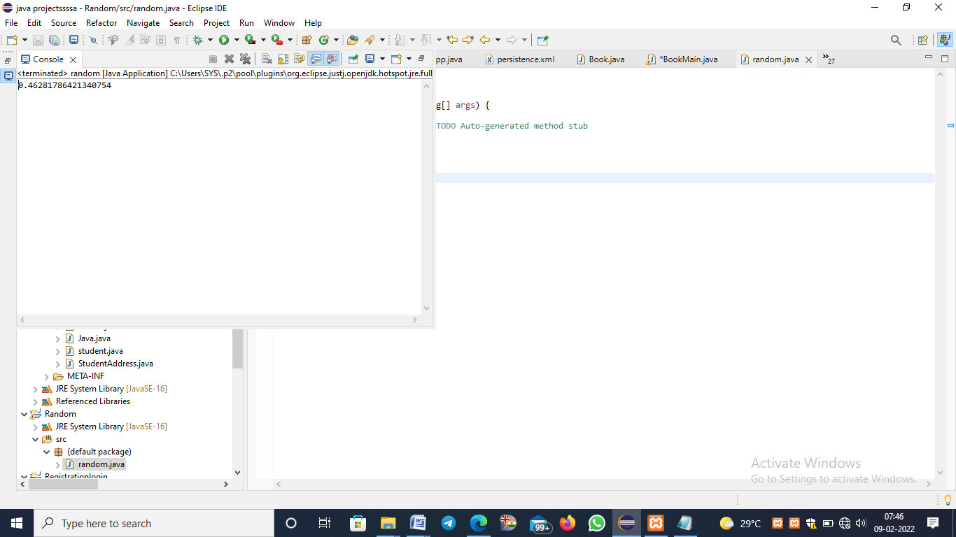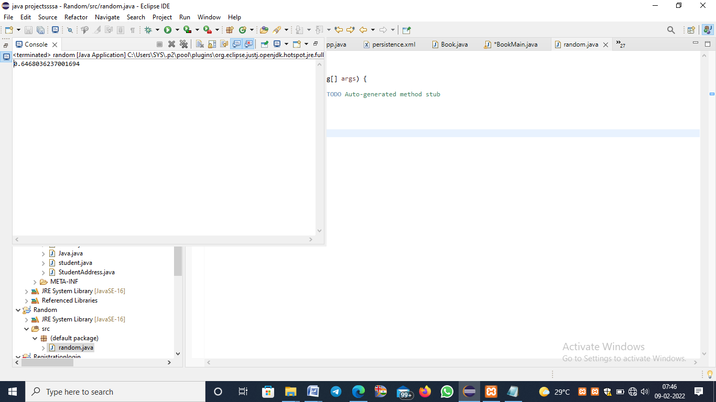

If i multipled the above program with 100000 it will display in the below manner

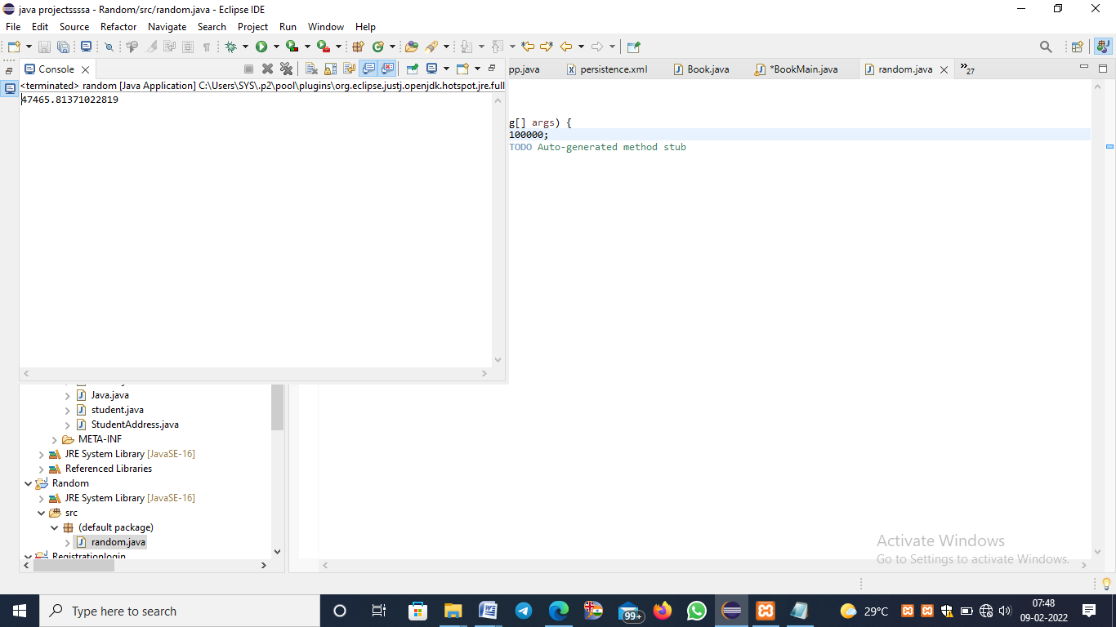

But it shows the value in double manner only i want 5 digit integer number for that i used typecasting to convert into integer.

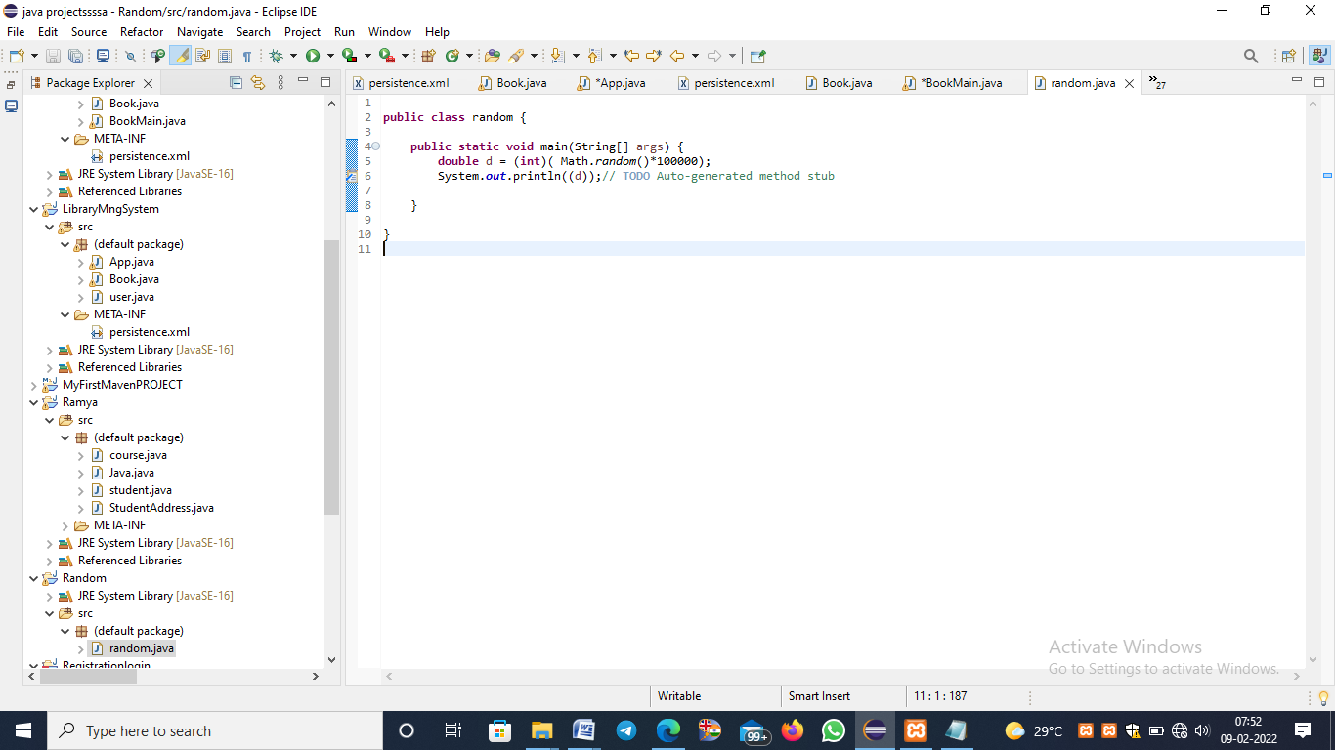

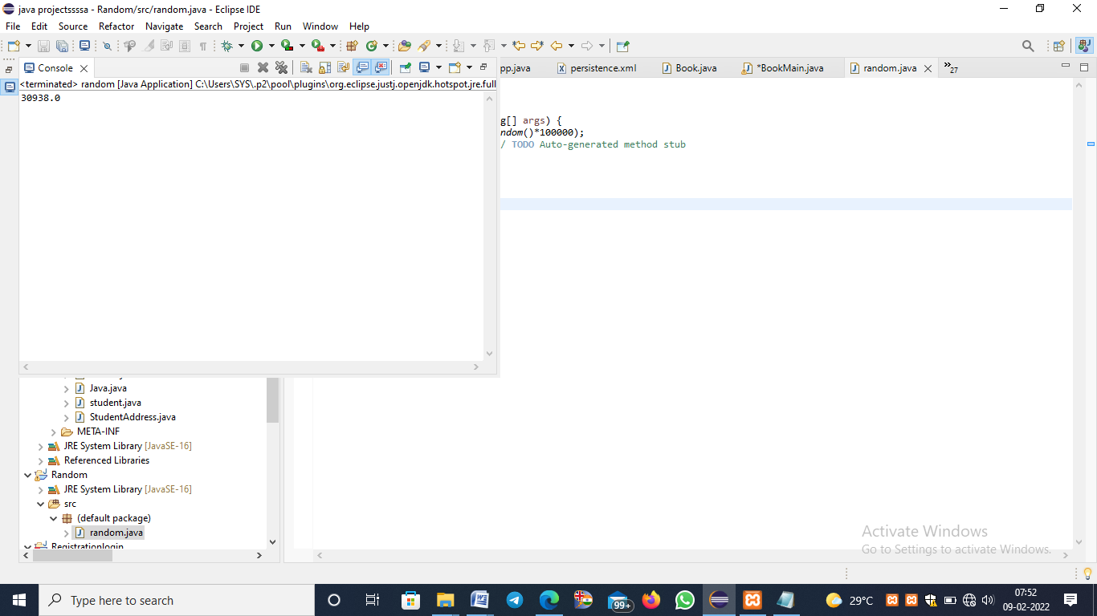

**CONCLUSION:**

With the help of this project I came to know how to work with the random function and then the core Java concepts.In this project I learned how to print the n student records for using some of the functions of objects and methods and then the help of pojo file.In future i can implement this project using database functions.